**Exercise 2: Implementing the Factory Method Pattern**

**Scenario:**

You are developing a document management system that needs to create different types of documents (e.g., Word, PDF, Excel). Use the Factory Method Pattern to achieve this.

**Program:**

interface Document {

void open();

}

class WordDocument implements Document {

public void open() {

System.out.println("Opening Word Document");

}

}

class PdfDocument implements Document {

public void open() {

System.out.println("Opening PDF Document");

}

}

class ExcelDocument implements Document {

public void open() {

System.out.println("Opening Excel Document");

}

}

abstract class DocumentFactory {

public abstract Document createDocument();

}

class WordFactory extends DocumentFactory {

public Document createDocument() {

return new WordDocument();

}

}

class PdfFactory extends DocumentFactory {

public Document createDocument() {

return new PdfDocument();

}

}

class ExcelFactory extends DocumentFactory {

public Document createDocument() {

return new ExcelDocument();

}

}

class Main{

public static void main(String[] args) {

DocumentFactory factory = new PdfFactory();

Document doc = factory.createDocument();

doc.open();

}

}

**Output:**

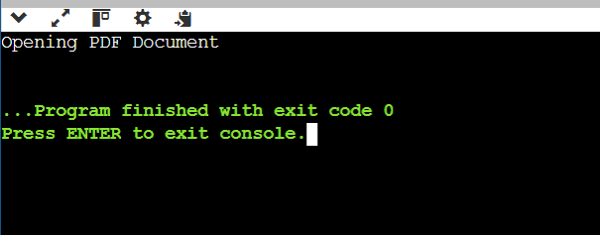

**Exercise 7: Implementing the Observer Pattern**

**Scenario:**

You are developing a stock market monitoring application where multiple clients need to be notified whenever stock prices change. Use the Observer Pattern to achieve this.

**Program:**

import java.util.*;

interface Observer {

void update(float price);

}

interface Stock {

void register(Observer o);

void deregister(Observer o);

void notifyObservers();

}

class StockMarket implements Stock {

private List<Observer> observers = new ArrayList<>();

private float price;

public void setPrice(float price) {

this.price = price;

notifyObservers();

}

public void register(Observer o) {

observers.add(o);

}

public void deregister(Observer o) {

observers.remove(o);

}

public void notifyObservers() {

for (Observer o : observers) {

o.update(price);

} } }

class MobileApp implements Observer {

public void update(float price) {

System.out.println("Mobile App - Stock price updated to Rs." + price);

}

}

class WebApp implements Observer {

public void update(float price) {

System.out.println("Web App - Stock price updated to Rs." + price);

}

}

class TestObserver {

public static void main(String[] args) {

StockMarket market = new StockMarket();

Observer mobile = new MobileApp();

Observer web = new WebApp();

market.register(mobile);

market.register(web);

market.setPrice(350.0f);

}

}

**Output:**

